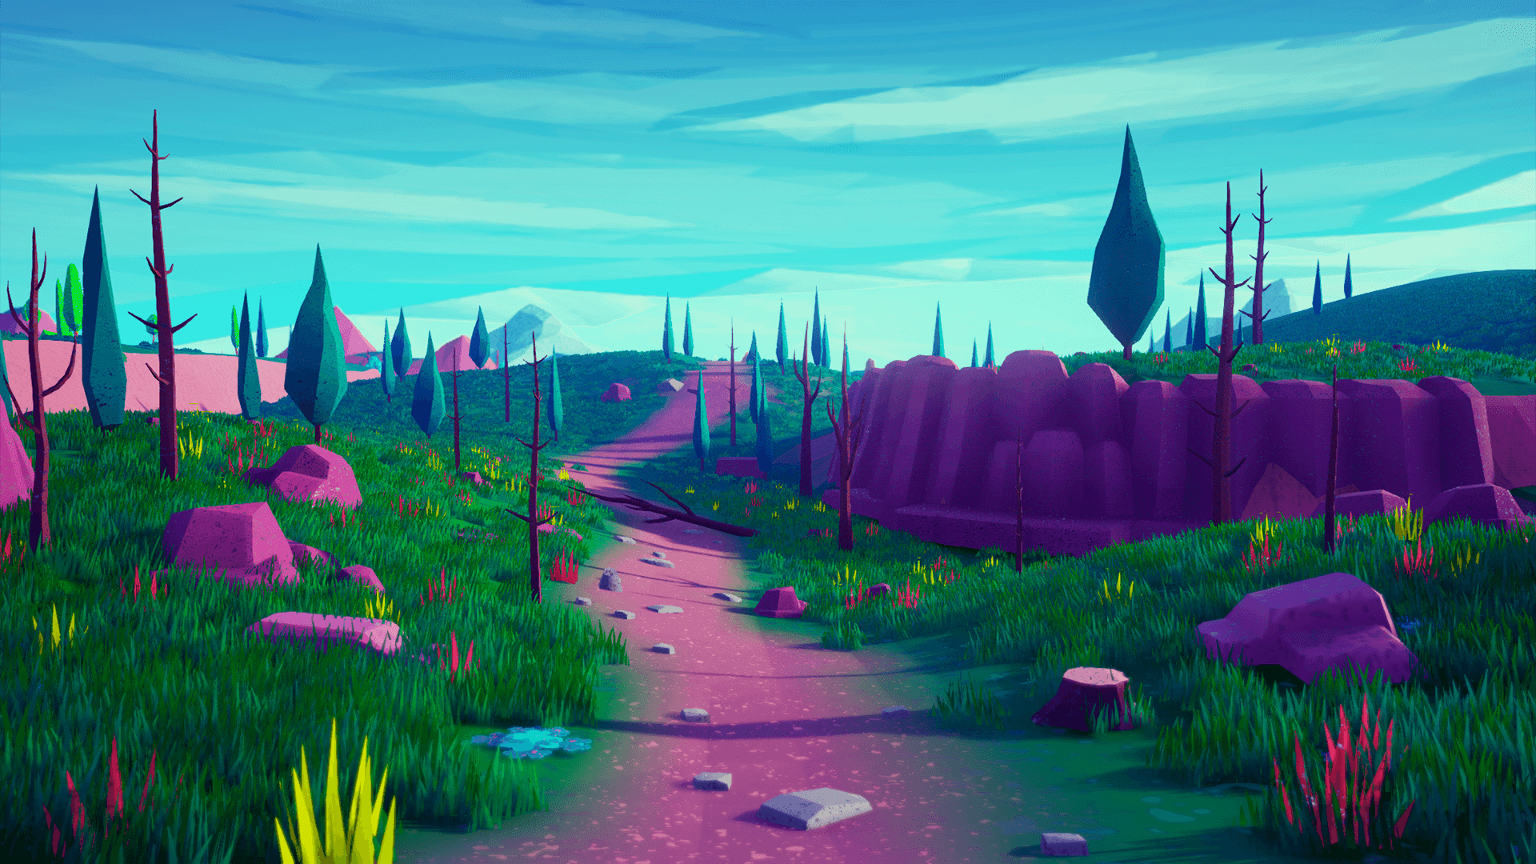
Programming with Teens at NHFP

Overview:

Students will participate in creating their own digital worlds and then building navigation systems to fly through their creations.

Over the course of several weeks, students will plan, design, create and review their own digital world.
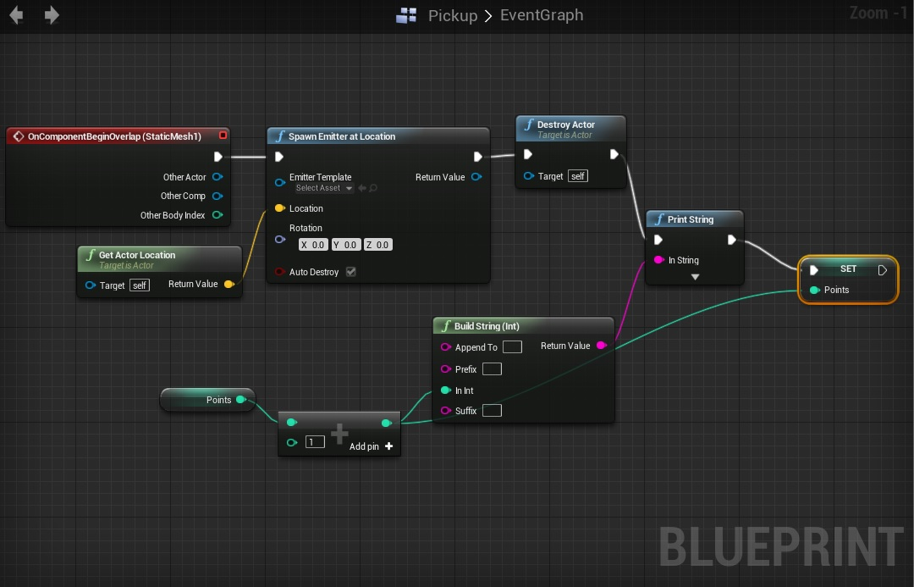
//

Possible workshop Ideas :
awaiting brainstorm meeting with Meghan Currey

- Compose Photo Romans in Unreal Engine and remix classic cinema storyboards
- Learn to Code via Video Game Making
- Camera Tricks using common DSLRs
  - Light Painting - Green Screen - Stroboscopic
- Web Design
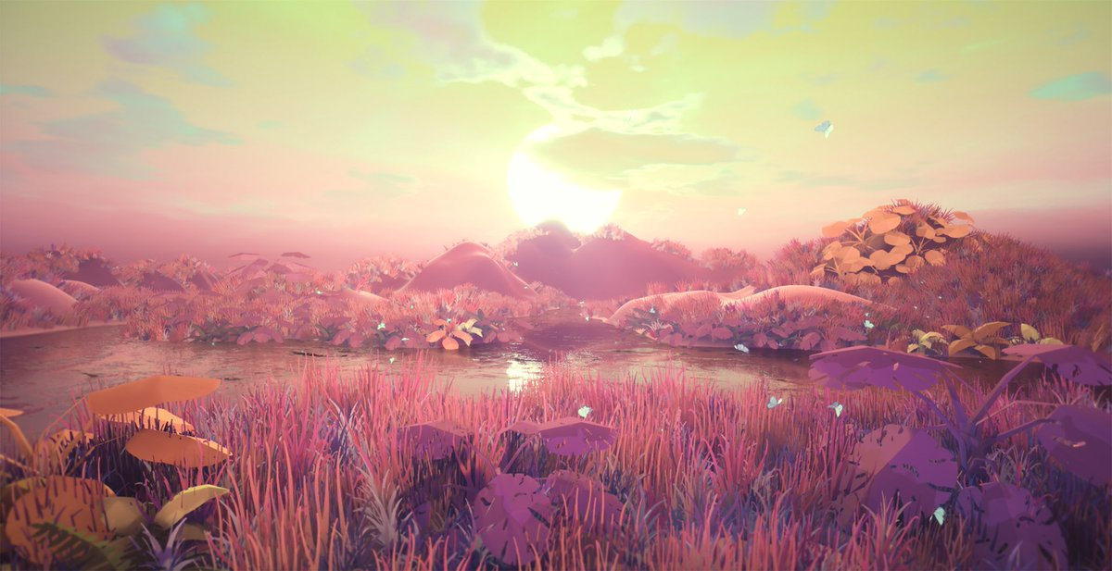
  - Designing for Small Business
  - Online Resume and CVs
  - Designing eCommerce Websites
- Create your own Virtual Reality Art Gallery
- Create your own Virtual Reality Poem
  - Combine audio poem & a visual experience

